Date : 27/12/25 – 30/12/25
What is devops? Why we are using? 5 W's of Devops
Responsibilites?
Emerging new Ides in DEvops - DevSecOps MlOps AiOps

Pipes(|) in Linux
Linux OS?
What is Git?

DEVOPS
Why DevOps?
In the past, software delivery was slow and full of manual work. Developers used to create separate feature branches and worked on them for weeks or even months.
- All these branches were merged at the end, which often caused big conflicts and broken builds. Testing and building the code were also manual, usually done at the final stage, so bugs were discovered very late and were costly to fix.
- Deployment was a long and risky process, taking days or sometimes weeks, because everything was released together in one big update.
- Teams were also divided: developers wrote code, testers tested it, and operations managed servers.
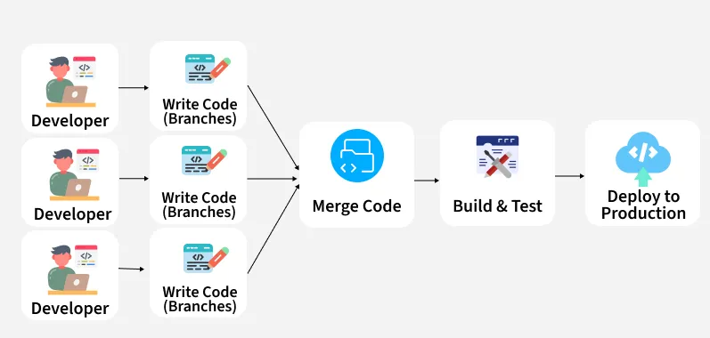

After DevOps
The whole process became faster, automated, and more reliable. Developers now commit their code frequently to a shared main branch, which prevents conflicts and ensures smooth integration.
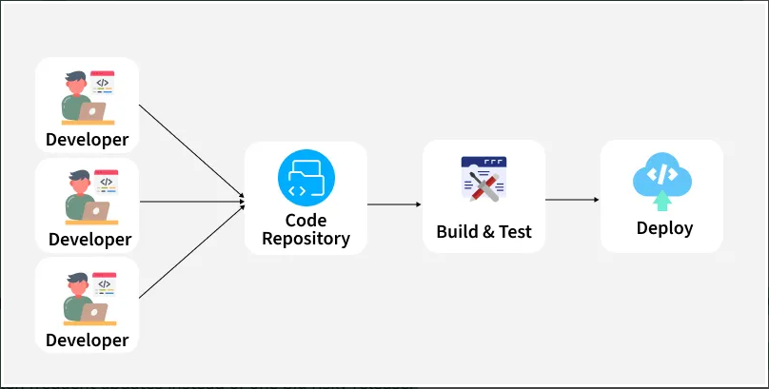
- Automated pipelines run tests, builds, and checks as soon as code is pushed, so errors are caught early. Continuous Delivery makes sure that tested code is automatically packaged and ready for deployment
- While Continuous Deployment takes it a step further by directly releasing to production without manual steps. This means smaller, frequent updates instead of one big risky release.
- Tools like Git, Jenkins, Docker, and Kubernetes automate everything from building to deployment, making the workflow transparent and collaborative. Bugs are fixed quickly, rollbacks are easier, and overall software delivery happens in hours instead of days
Analogy:
Before DevOps:
- Chefs cook pizza
- Delivery team delivers pizza
- They never talk
Chef says:
“I made the pizza.”
Delivery says:
“The pizza is cold and late.”
Customer is angry
With DevOps:
- Chefs and delivery work together
- They plan cooking + delivery timing
- Pizza arrives hot and fast
Happy customer

What was used before DevOps?
System Administrator – Creates a server
- IT professional who installs, configures, maintains, and troubleshoots an organization's computer systems, servers, networks, and software
BRE(Build and Release Engineer) - Deploys the app on the server
Server Administrator – Creates Application server that manages app deployed on the server.
- All this includes manual efforts and hence takes longer time to deploy, so Devops engineer came into play to automate this task and faster to deploy.

What is Operations?
All the activities required to run, maintain, and support software after it is deployed for users.
Analogy
If a game app is made:
- Developers build the game
- Operations keep the game running on servers

Operations includes work like:
- Managing servers (computers that run the app)
- Deploying the application (putting it live)
- Monitoring (checking if it’s slow or down)
- Security
- Backups and recovery
- Fixing outages (incidents)
What is DevOps?
DevOps is all about automating and streamlining the software development lifecycle(SDLC) so that code delivery moves from development to production quickly, reliably, and securely.
OR
DevOps practices enable software development (dev) and operations (ops) teams to accelerate delivery through automation(CI/CD), collaboration, fast feedback, and iterative improvement.
DevOps focuses on incremental development and rapid delivery of software.
Online shopping app
- Developers add a new “Buy Now” button
- Operations make sure the app is running on servers 24/7
Key Goals:
• Faster software delivery
• Improved Collaboration
• Increased Deployment Frequency
• Reliable releases
• Enhanced quality and security
• Improved monitoring and feedback loop
• Scalability and flexibility

How DevOps is used?
DevOps is implemented using:
- CI/CD pipelines
- Infrastructure as Code
- Monitoring
- Automation tools
- Cloud platforms
It creates a continuous loop:
Plan → Code → Build → Test → Release → Deploy → Operate → Monitor → Improve
What are the Responsibilities of an DevOps Engineer?
A DevOps Engineer is responsible for:
Automation
- CI/CD pipelines
- Automated testing
- Automated deployments
Infrastructure
- Cloud setup (AWS, Azure, GCP)
- Infrastructure as Code (Terraform, CloudFormation)
System Reliability
- Monitoring
- Alerting
- Incident response
Security (shared)
- Secure pipelines
- Access control
Collaboration
- Bridge between Dev & Ops
- Improve release processes
- Reduce deployment failures
CI/CD
1. Continuous Integration (CI)
- The Goal: Prevent "Integration Hell."
- The Process: Developers merge their changes back to the main branch as often as possible (daily).
- The Automation: Upon every commit, an automated system builds the code and runs unit tests. If a test fails, the build is rejected, and the developer is notified immediately.
2. Continuous Delivery (CD)
- The Goal: Be ready to release at any moment.
- The Process: After CI passes, the code is automatically deployed to a staging/testing environment. Extensive integration and load tests are run.
- The Release: The codebase is always in a deployable state, but the push to production is a manual decision (e.g., a "Deploy" button click by a manager).
3. Continuous Deployment (CD)
- The Goal: Eliminate human intervention.
- The Process: Same as Continuous Delivery, but if all automated tests pass in staging, the code is automatically deployed to production.
- The Requirement: Requires extremely robust, trustworthy automated testing suites
What are the new emerging stacks in DevOps like AiOps, MLOps, DevSecOps?
LifeCycle Stages of DevOps?
- Plan: This phase focuses on understanding the business needs and gathering feedback from end-users.
Jira, Trello, Asana
- Code: In this phase, developers write the actual code for the software. Tools like Git help manage the code, making sure that the code is well-organized and free from security issues or bad coding practices.
Git, GitHub, GitLab, Bitbucket
- Build: Once the code is written, it is submitted to a central system using tools like Jenkins. This step ensures the code is compiled, and all components are integrated together smoothly.
Jenkins, Maven, Gradle
- Test: The software is then tested to ensure it works properly. This includes different types of tests like security, performance, and user acceptance. Tools like JUnit and Selenium are used to automate these tests and verify the software’s integrity.
Selenium, JUnit, TestNG, SonarQube
- Release: After testing, the software is ready to be released to production. The DevOps team ensures that all checks are passed and then sends the latest version to the production environment.
- Deploy: Using Infrastructure-as-Code (IaC) tools like Terraform, the necessary infrastructure (servers, networks, etc.) is automatically created. Once the infrastructure is set up, the code is deployed to various environments in an automated and repeatable way.
ArgoCD, GitLab CI/CD, AWS CodeDeploy, Azure DevOps, Spinnaker, Terraform
- Operate: Once deployed, the software is available for users. Tools like Chef help manage the configuration and ongoing deployment of the system to ensure it operates smoothly.
Terraform, Ansible, Puppet, Chef
- Monitor: This phase involves observing how the software is performing in the real world. By monitoring the system, the team can quickly spot and fix problems that may affect performance.
Prometheus, Grafana, ELK Stack, Datadog
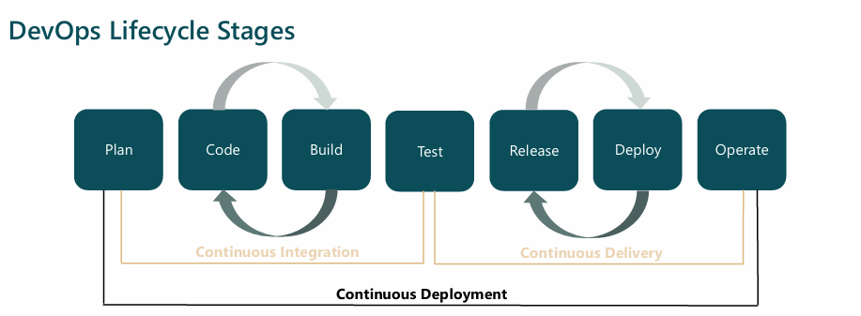

Analogy
DevOps Phase | Pizza Restaurant Meaning
Plan | Collect customer feedback, decide menu
Code | Define recipes and cooking instructions
Build | Prepare dough and assemble ingredients
Test | Quality check: taste, size, hygiene
Release | Approve pizza for sale
Deploy | Use ovens & delivery system to serve
Operate | Run the restaurant daily
Monitor | Track orders, delays, complaints

Professional Insights
- Automation = same pizza quality every time
- CI/CD = pizza flows smoothly from kitchen to customer
- IaC (Terraform) = building ovens and kitchens automatically
- Monitoring = customer reviews, delivery time, sales data
- Feedback loop = improve recipe continuously

Linux
Why do we need an Operating System (OS) at all?
A computer without an OS is just hardware — CPU, RAM, disk, keyboard — all silent and useless.
An OS exists to:
- Talk to hardware
Apps don’t know how to speak “CPU” or “disk controller.” The OS does that for them.
- Manage resources
  - Who gets the CPU right now?
  - How much RAM can each program use?
  - Where are files stored on disk?
- Keep things safe
Prevent one app from:
  - Reading another app’s memory
  - Crashing the whole system
  - Stealing data
- Provide a platform for apps
Apps rely on OS services instead of reinventing everything.
Without an OS, every program would need to be written specifically for your exact hardware, which is a nightmare.
Then why Linux and other operating systems?
Because different needs → different design choices.
No single OS is best for everything.
Why Linux exists
Linux was created to be:
- Free & open-source – anyone can inspect, modify, and share it
- Highly customizable – from phones to supercomputers
- Stable & reliable – servers can run for years without rebooting
- Efficient – great control over system resources
That’s why Linux dominates:
- Servers
- Cloud infrastructure
- Embedded systems
- Android devices
- Supercomputers
Linux is less about “pretty UI” and more about control and power.

Other OS
Why Windows exists
Windows focuses on:
- Ease of use
- Gaming
- Commercial software compatibility
- Enterprise desktop environments
It prioritizes:
- Backward compatibility
- Plug-and-play hardware
- Mass-market usability
Perfect for:
- Home users
- Offices
- Gamers
Why macOS exists
macOS is about:
- Polished user experience
- Tight security
- Deep integration with Apple hardware
- Developer-friendly UNIX base
Great for:
- Creative professionals
- Apple ecosystem users
- Developers who want UNIX + nice UI

Architecture of Linux
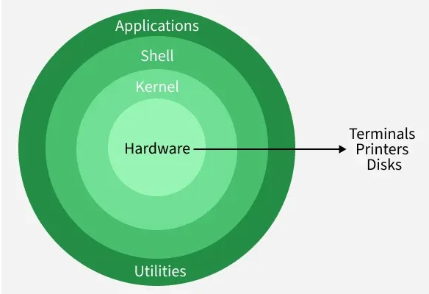
1. Hardware Layer
The hardware layer consists of physical components that execute commands and provide system resources.
- Includes CPU, RAM, storage, and input/output devices.
- Communicates with the OS using device drivers and kernel services.
2. Kernel
The kernel is the core of the Linux operating system that manages hardware resources and controls communication between software and hardware.
- Handles process management, memory, and device control.
- Prevents conflicts between multiple running programs.
Types of Kernels: Monolithic, Microkernel, Hybrid, Exokernel
3. Shell
The shell is the command-line interface that allows users to communicate with the operating system by entering commands.
- Interprets and executes user commands.
- Acts as a bridge between user actions and kernel processing.
4. System Libraries
System libraries provide essential functions that allow applications to interact with the kernel without needing to access it directly.
- Contain reusable pre-written code for common system operations.
- Act as an interface between applications and the Linux kernel.
5. System Utilities
System utilities are built-in tools that help users manage, configure, and maintain the operating system.
- Used for tasks like software installation, user management, and monitoring.
- Simplify system administration processes for both beginners and administrators.
Analogy: Linux as a Corporate Office Building
1. Hardware Layer → Office Building & Machines
Analogy:
The building and machines of the company.
Employees cannot directly control machines — they need permission and instructions.
2. Kernel → The CEO (Core Management)
Analogy:
The CEO of the company.
- Decides who works when → process scheduling
- Decides how much desk space each employee gets → memory management
- Controls access to machines → device drivers
- Prevents fights over resources → conflict prevention
Only the CEO is allowed to directly control machines.
Types of CEOs (Kernel Types):
- Monolithic → CEO does everything personally
- Microkernel → CEO delegates most tasks
- Hybrid → Mix of direct control + delegation
- Exokernel → CEO only enforces rules, employees manage tools themselves

3. Shell → Reception Desk / Secretary
(Command-line interface)
Analogy:
The receptionist or secretary.
- Takes requests from employees (users)
- Translates them into official instructions
- Sends them to the CEO (kernel)
Example:
User types ls → Secretary converts it → CEO processes it
4. System Libraries → Office Assistants & Rulebooks
(Reusable system functions)
Analogy:
Assistants and company manuals.
- Employees don’t bother the CEO for every small task
- Assistants know standard procedures
- Reusable instructions save time and effort
Example:
Instead of asking CEO directly → assistant prepares the request correctly.
5. System Utilities → Maintenance & Admin Staff
(Management tools)
Analogy:
Maintenance crew and admin staff.
- Install new equipment (software installation)
- Manage employees (user management)
- Monitor company performance (system monitoring)
- Keep everything running smoothly
Used by:
- Regular staff
- System administrators (IT managers)

🔄 How Everything Works Together (Flow)
- Employee (User) makes a request
- Secretary (Shell) understands it
- Assistant (Library) prepares instructions
- CEO (Kernel) approves and controls access
- Machines (Hardware) do the actual work
HYPERVISOR
Why Hypervisor ?
A hypervisor is used because it is the safest, fastest, and most controlled way to share one physical machine among multiple operating systems without conflicts.
Nothing else before it could do all three at once:
- Isolation
- Efficient resource sharing
- Multiple OS support
What Was Used Before Hypervisors?
- Era 1: One Server = One OS (Bare Metal Only)
One family living in a huge house—even though most rooms are empty.
Problems
- Massive hardware waste (CPU often <10% used)
- Expensive (more servers = more power, space, cooling)
- Poor scalability
- Long deployment times
➡️ Servers were powerful, but badly underutilized

- Era 2: Dual Boot / Time Sharing
What changed
- Multiple OS installed
- Only one OS runs at a time
Analogy:
Multiple drivers sharing one car—but only one can drive, everyone else waits.
Problems
- No simultaneous execution
- Frequent reboots
- Still inefficient

- Era 3: Application-Level Sharing (Early Hosting)
What changed
- One OS
- Many applications/users
Analogy:
Many people sharing one kitchen—if one messes up, everyone suffers.
Problems
- No OS isolation
- Security risks
- App conflicts
- One crash affects all

Why Not Just Use the OS Itself?

OS is not designed to manage other OSs

Analogy:

A tenant cannot also be the building manager.
What is Hypervisor?
- A hypervisor (or Virtual Machine Monitor, VMM) is software that lets multiple operating systems run on a single physical machine.
- It manages hardware resources (CPU, memory, storage) and allocates them to virtual machines (VMs) without interference.

Analogy
- Physical server → The apartment building
- Hypervisor → The building manager
- Virtual machines (VMs) → Individual apartments
- CPU, RAM, storage → Electricity, water, gas

How it works?
- A hypervisor runs on hardware or a host OS to create and manage virtual machines (VMs), each with its own virtual CPU, memory, storage, and network.
- It intercepts guest OS requests and translates them to physical hardware, ensuring isolation, security, and stability.
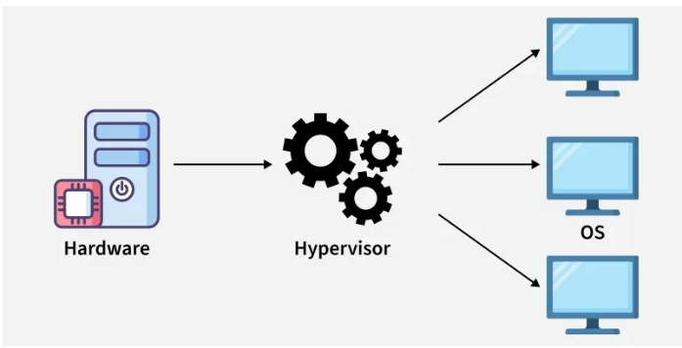

Why two different type of Hypervisor?
Goal | Type-1 Hypervisor | Type-2 Hypervisor
Performance | ✅ Maximum | ❌ Lower
Security | ✅ Strong | ❌ Depends on host OS
Ease of use | ❌ Complex | ✅ Very easy
Hardware access | Direct | Through host OS
You can’t optimize all of these at once.
That’s why two types exist.
Types of Hypervisor
There are two main types of hypervisors, each with a different architecture:
1. Type 1 Hypervisor
A Type 1 hypervisor runs directly on the host's hardware. It doesn't rely on a host operating system. This architecture offers better performance and security because there is no intermediary OS. It's the standard for enterprise-level data centers and cloud providers like Amazon Web Services (AWS) and Microsoft Azure.
Examples: VMware ESXi, Microsoft Hyper-V, KVM (Kernel-based Virtual Machine), and Xen.
Pros:
- High performance (direct hardware access).
- Strong security (no intermediate OS layer).
- Suitable for mission-critical workloads.
Cons:
- Requires dedicated hardware.
- Setup and management are complex compared to Type-2.

Analogy: Hotel 🏨
- Hardware → Hotel building
- Type 1 Hypervisor → Hotel management system
- VMs → Guest rooms

2. Type 2 Hypervisor
A Type 2 hypervisor runs on top of a conventional operating system (like Windows, macOS, or Linux). It's essentially an application within the host OS. This type is generally used for desktop virtualization, development, and testing environments where a user needs to run multiple OSs on their personal computer. Performance is slightly lower than Type 1 due to the overhead of the host OS.
Examples: Oracle VM VirtualBox, VMware Workstation, and Parallels Desktop.
Pros:
- Easy to install and use.
- Useful for development, testing, and malware analysis.
- Provides good host–guest integration features.
Cons:
- Slower performance (no direct hardware access).
- Security depends on the host OS; compromise of host may affect guests.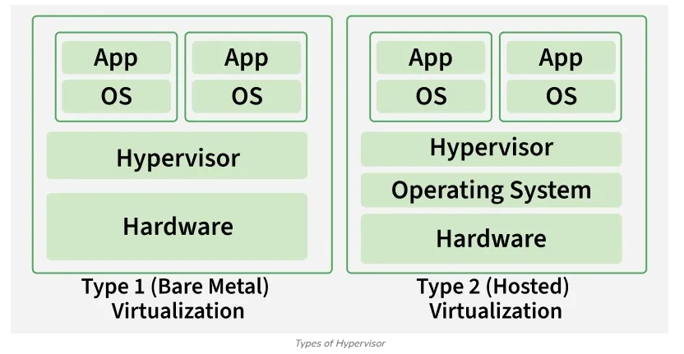
Analogy: House with Guests 🏠
- Host OS → Homeowner
- Type 2 Hypervisor → Guest app
- VMs → Guests
Setup of Two Different Types of Hypervisor.
Type-1 Hypervisor
What you do:
- Install hypervisor directly on bare hardware
- Configure BIOS/UEFI (VT-x / AMD-V, IOMMU)
- Partition disks manually
- Configure networking before you even create VMs
Analogy:
Building a house from scratch—you must plan plumbing, electricity, and layout first.
Type-2 Hypervisor
What you do:
- Download software
- Click “Next → Next → Install”
Analogy:
Installing a new app on your phone.

